Ecosystems at Risk: limestone caves
Name: Teacher
1. Introduction
1ai. Define the terms:
ecosystem: | any given space in which plants and animals interact with each other and the  physical environment. In this case ‘any given space’ is the cave.
troglobite: | animals which live in caves
speleothem: | cave formations such as stalactites.
1aii. Explain why caves are 'ecosystems at risk'. Cave animals have evolved to survive in a very stable environment with very specific features including low temperatures, high humidity and CO2. The formation of speleothems depends on a delicate balance of CO2 in the cave atmosphere.
2a. World Location
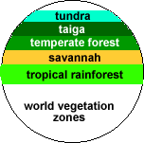
a. Vegetation forms general latitudinal bands around the world with tropical rainforests near the equator and tundra near the poles. However the location of limestone geology where limestone caves form does not follow a similar neat zonation pattern. Describe limestone geology under the following headings:

2ai. latitude | Caves are found at all latitudes, it is not a factor in their location.
2aii. continuity | On a world scale, limestone caves are discontinuous features within  limestone geology which itself is discontinuous.
2aiii. size and shape | Caves vary greatly in their size from a few metres to the longest cave  in the world which is over 500 km long. Their are usually long, narrow  features, forming along joint planes in limestone.
2aiv. Describe the world location of limestone caves. They are dispersed and occur in every continent except Antarctica which might because they are presently hidden beneath the ice cap. Many caves coincide with mountainous areas, however this is not always the case with karst occuring in flat areas such as the Nullarbor Plain in Australia.
2av. List the countries with the 5 longest and 5 deepest cave systems.
Countries with the longest caves. | Countries with the deepest caves.
USA | France
Ukrain | Austria
Switzerland | France
USA | Georgia
Switzerland | Mexico
New South Wales, location
2avi. Name 5 towns located near limestone caves. Armidale, Tamworth, Wellington, Yass, Bathurst
2avii. Describe the continuity of cave areas in New South Wales. They mainly occur in the Eastern Highlands and not in the west of the state.
2b. Topographic Map
2bi. What features are located at the following grid references (GR):
i. GR345453 | ii. GR343454 | iii. GR351459
sink hole | Jersey cave | Radio hut
2bii. What are the approximate straight line distances of:
i. Radio Hut to Jersey Cave | ii. Thermal Pool to Jersey Cave | iii. Jersey Cave to Ranger Station
1.0 km | 0.8 km | 0.5 km
2biii. What is the altitude of the following features:
i. Radio Hut | ii. shed at GR 349449
1130 m | 1035 m
2biv. North is to the top of the map. What is the direction of:
i. ranger station from thermal pool | ii. thermal pool from Glory Hole Cave
NE | S
2bv. Landform
Describe the general landform using all of the information on the page. Hills and valleys with the Yarrangobilly River in a deep gorge with cliffs.
3a. Climate
3ai. How does the climate inside caves differ to that outside? List 5 of the major differences. High humidity, cool temperatures, no light, no rain, very stable climate with little variation
3aii. Name the three main climatic zones in caves. entrance, twilight, dark

3aiii. Compare the seasonal temperature range inside caves to that outside in the Yarrangobilly area.
Kiandra has a range of 14 deg to 1 deg (13) and caves vary from approx. 11-9 (2)
3aiv. In which months of the year is the temperature inside the caves warmer than the average daily temperature outside.
Temperatures are warmer in the caves from March to November and cooler from November to March.
3b, c&d. Climate of the entrance, twilight and dark ecosystems
3bi. Fill in the following table after calculating the readings. Record the light and wind readings for 10 seconds then obtain the averages and record them.
climatic element | entrance | twilight | dark
air temperature (deg. C) | 22 | 15 | 9
relative humidity (%) | 46 | 52 | 84
light intensity (lux) | approx. 16-17000 | approx. 500 | 0
wind speed (m/s) | approx 0.6 | approx. 0.2-0.3 | approx 0.1

3bii. Describe how the following change as you go deeper into the cave:
a. air temperature: it decreases from 22 to 9 degrees. It also has less diurnal and seasonal fluctuation.
b. relative humidity: relative humidity increases dramatically. It depends on how wet the cave is but with cool temperatures and water dripping through, humidity is usually very high.
c. light intensity : light intensity decreases quickly from the entrance to inside. Individual caves vary depending on the size of the entrance.
4a. Landform: cave formation
4ai. What is the term which describes the breaking down of rock? | weathering
4aii. Which type of weathering, physical or chemical, is mainly responsible for cave formation? | chemical
4aiii. Name the weak acid responsible for the dissolving of limestone and state where most of the carbon dioxide for its formation comes from.
Carbonic, CO2 mainly comes from the soil as the water seeps through it and some from the atmosphere.

4aiv. How did the limestone for these caves form and how long ago did this occur? shells of sea animals about 440 million years ago – coral reef
4av.. Soil forms from weathered rock. Soil acidity is an important soil characteristic. What is the approximate pH of the small soil sample tested? | 9 very alkaline
4b. Landform: speleothem formation
4bi. Write the names of speleothems (cave formations) on the diagram.
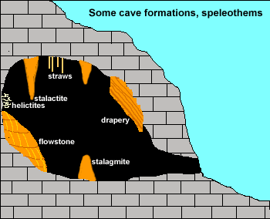
4bii. Explain how stalactites form. Deposition of calcite caused by outgassing of carbon dioxide gas.
4c. Landforms: catchments
4ci. What term is used to describe limestone areas and what are some of the major landform features found there? karst: gorges, sink holes and dry valley

4cii. Construct a transect from spot height 1143 m to the river at the Natural Bridge.
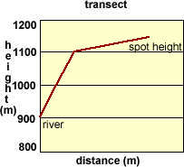
4ciii. Calculate the average gradient from spot height 1143 m to the river at the Natural Bridge.
(gradient = difference in height divided by horizontal distance and is expressed as a fraction)
(gradient = difference in height divided by horizontal distance and is expressed as a fraction) 343 m over 900 m = 1 : 2.6 steep

4civ. Why might using this gradient give the wrong impression if you used it to describe landform here?
The gradient is the average slope over the distance it is calculated for. In this instance the slope near the river is almost a cliff while that further up is much less steep.

4cv. Explain why are limestone areas often dry on the surface? Sink holes capture the streams which then flow underground.
5a. Ecology
5ai. What do food chains show? The flow of energy from plant to herbivore to carnivore.
5aii. Explain how are cave food chains different to typical forest food chains?
A typical food chain contains plants which convert solar energy into chemical energy by photosynthesis and this is passed on down the chain. Dark cave ecosystems have no solar energy and no plants so depend on matter such as plant and animal material being transported into the cave for the resident animals to eat.
5b. Ecology: food chains
5bi. Describe how species diversity (the number of different types of plants and animals) and biomass (the weight of plant and animals in an area) vary as you move deeper into a cave from the entrance?
The entrance ecosystem has a greater biodiversity and biomass with access to solar energy and plants and animals on the surface. As you go deeper into caves the influence of surface organisms and solar energy decreases and biodiversity and biomass decreases dramatically.

5bii. Compare the world averages for the biomass of tropical rainforest and dark cave ecosystems?
The world biomass average for tropical rainforests is 45 kg/m2. Caves have much lower biomass quantities with typical figures around 0.002 kg/m2 however this figure varies from cave to cave.
5biii. Describe the cave floor and cave roof communities. Cave roof communities include bats and birds and their parasites which vivit the outside world for feeding. The floor community is more complex and relies on waste from the roof community for it’s food supply. It includes cockroaches, spiders etc.
5c. Adjustments to Stress
a. Fill in the following table.
Features of the cave environment | Animal adaptations to the cave environment
no light | loss of pigmentation
low temp. | reduced size
high humidity | loss of sight
high carbon dioxide | long antennae
no plants | long legs
6. Change
a. Explain why most cave animals are unable to survive very minor changes to the cave environment.
They have evolved to live in a very stable environment. They have lost their resistance to survive a changing environment.
7a. Human impact in catchments
7ai.Explain why human activities in cave catchments have a large impact on the caves which are underground? Caves are formed from the movement of underground water which originated on the surface so any changes to the land above caves which impacts on the quantity or quality of the water will impact on the caves. Caves also depend on the carbon dioxide levels of water so changes to the soil or vegetation will impact on this.
7aii. List some of the activities people do which change cave catchments. Changing the vegetation such as with farming or pine plantations will change soil characteristics, perhaps increase erosion, roads, housing, tourism infrastructure such as camping areas
7aiii. Draw a precis map in the space showing human changes shown in the Yarrangobilly air photo. The topographic map on page 2b will help.
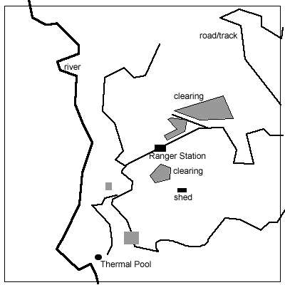
7b. Human impact in caves
7bi. List the different changes made to show caves to allow guided tours. Lighting, widen entrances, widen passages, steps, paths built, gates which impede animal movement.
7bii. Describe some of the impacts people have on caves when the visit them.
Introduce food, trample cave floor community, disturb roof community, warm cave air, decrease cave humidity

8a. Catchment Management
8ai. Explain how the government has protected caves.
Many caves are within national parks. Legislation means a government body such as the National Parks and Wildlife Service in NSW is responsible for their management and will have developed a management plan for ecologically sustainable use.
8aii. Why is catchment management important? Although caves appear to be isolated features, they are connected to the surface by the flow of water so anything which impacts on the catchment water cycle is likely to impact the caves as well.
8aiii. Give three examples of catchment management in the Yarrangobilly and Cooleman Plain areas to protect the caves.
removal of pine plantation, relocation of camping areas outside the cave catchments, education programs.
8b. Cave Management
8bi. Name the 6 categories of caves in the NP&WS cave classification system used to assist cave management?
1. Public Access; 2.1 Special Purpose; 2.2 Outstanding natural Value; 2.3 Dangerous; 3.1 Wild; 3.2 Unclassified
8bii. List 6 of the specific cave management methods used at Yarrangobilly.
limiting access, permit system for cavers, limiting the size of groups for both guided caves and by caving groups, code of ethics includes: no carbide lamps, toileting in caves, walk in single file, remove muddy shoes in delicate passages, public access restricted to guided caves except one unguided cave.
8biii. Explain the dilemma for the NP&WS when managing caves? They must protect the caves but allow suitable use: ecologically sustainable use.

